Experiment No.: 1 Date:
Installing OpenCV on the Raspberry Pi
Aim: Installing open CV on the Raspberry Pi and running a quick test.
Theory: OpenCV (Open Source Computer Vision Library) is an open source computer vision and machine learning software library. OpenCV was built to provide a common infrastructure for computer vision applications and to accelerate the use of machine perception in the commercial products. Being an Apache 2 licensed product, OpenCV makes it easy for businesses to utilize and modify the code.
The library has more than 2500 optimized algorithms, which includes a comprehensive set of both classic and state-of-the-art computer vision and machine learning algorithms. These algorithms can be used to detect and recognize faces, identify objects, classify human actions in videos, track camera movements, track moving objects, extract 3D models of objects, produce 3D point clouds from stereo cameras, stitch images together to produce a high resolution image of an entire scene, find similar images from an image database, remove red eyes from images taken using flash, follow eye movements, recognize scenery and establish markers to overlay it with augmented reality, etc. OpenCV has a user community in the hundreds of thousands, and estimated number of monthly downloads exceeding 40 million. The library is used extensively in companies, research groups, hobbyists, and by governmental bodies such as NASA.
It has C++, Python, Java and MATLAB interfaces and supports Windows, Linux, Android and Mac OS. OpenCV leans mostly towards real-time vision applications and takes advantage of MMX and SSE instructions when available. A full-featured CUDA and OpenCL interfaces are being actively developed right now. There are over 500 algorithms and about 10 times as many functions that compose or support those algorithms. OpenCV is written natively in C++ and has a templated interface that works seamlessly with STL containers.

Procedure:
- Burn the latest version of the Raspberry Pi operating system on the SD Card
- Connect the SD card to a Monitor, Keyboard and Mouse.
- Connect to your local network
- And run the following commands below to install OpenCV
sudo apt-get update
sudo apt-get install python3-numpy
sudo apt-get install python3-opencv
sudo apt install python3-matplotlib python3-numpy
- Using the nano editor in the terminal write the following python code
Sample Code - 1BasicTestOpenImage.py
import cv2
image = cv2.imread("Pictures/image_goa.jpg")
cv2.imshow("Original", image)
cv2.waitKey(0)
cv2.destroyAllWindows()
- To run the above code, use the command, and note down the observation
sudo python3 1BasicTestOpenImage.py
Observation:
Installing openCV on the Pi
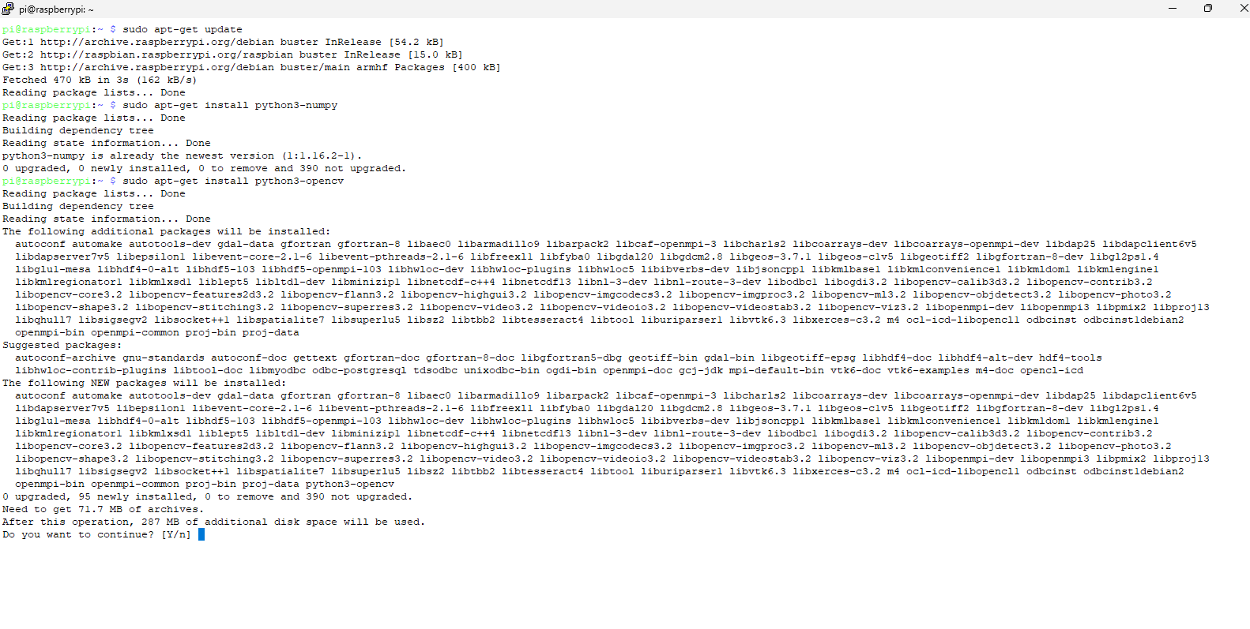
After running the python program
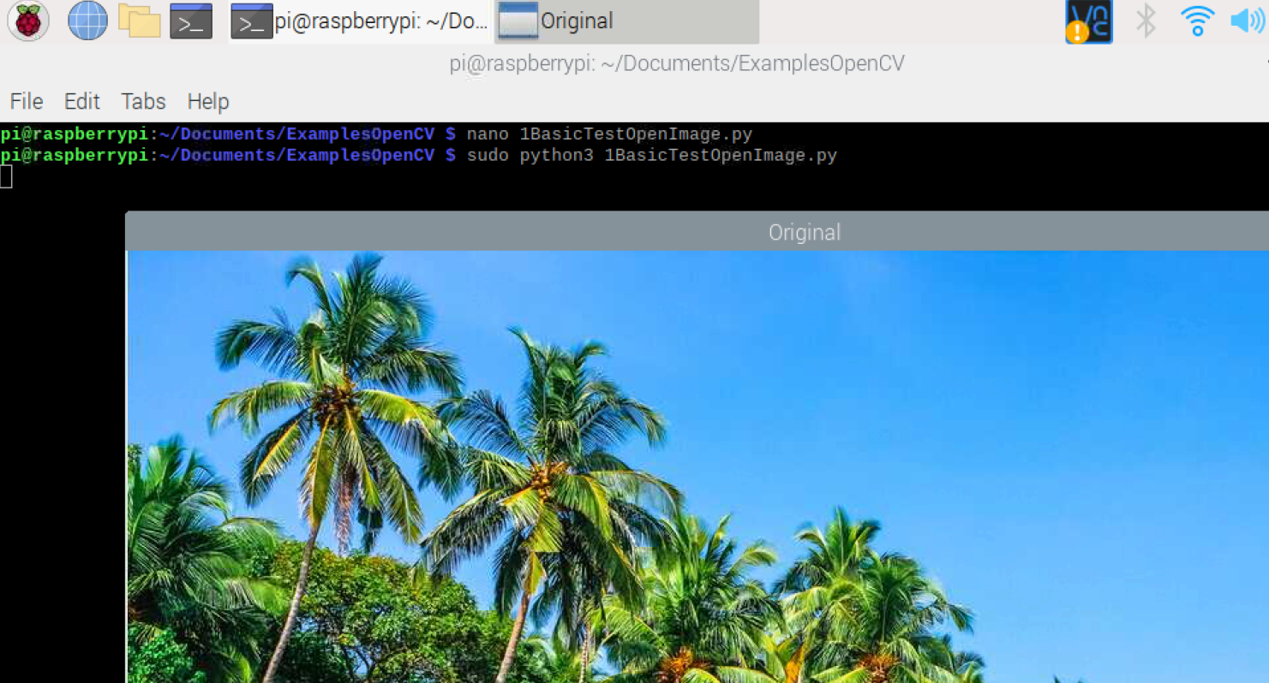
Conclusion: I was able to successfully install OpenCV on the Raspberry Pi.

